
SCHOOL OF COMPUTING AND ENGINEERING SCIENCES (SCES)
BACHELOR OF SCIENCE IN ELECTRICAL AND ELECTRONIC ENGINEERING
MULTIVARIATE CONTROL - LAB 1 REPORT
State-Space and Transfer Matrix Modelling and Simulation for MIMO Systems
By
Edward Aribu – 142092
Collaborators:
Alvin Nyandeje, Andrew Nzioki, Leo Mulama, Kimutai Ronny Kibiwott

Lecturer: Prof Mbuthia
Supervisor: Mr. Jamlick Ntonjira

Date: January 2026

Contents
List of figures 2
Abstract 4
1. Introduction 5
2. Preparations 5
2.1 Equipment and Software 5
2.2 System Parameters 5
3. Results and Analysis 6
3.1 Task 5.1 — 1/18 Scale FSD Car Lateral-Yaw Dynamics (Items 1 & 2) 6
3.1.1 Item 1: Mathematical Equations — State-Space Formulation 6
3.1.2 Item 2: Eigenvalue Analysis and Simulation Results 6
3.2 Task 5.2 — Hitbot Z-Arm S922 Forward Kinematics, Jacobian and Manipulability 9
3.2.1 Item 3: Forward Kinematics and Jacobian Equations 9
3.3 Task 5.3 — 'X' Quadcopter Nonlinear Attitude Dynamics 10
3.3.1 Item 5: Nonlinear Attitude Dynamics Equations 10
3.3.2 Item 6: Continuous-Time Response Plots 10
4. Discussion 11
4.1 Speed-Dependent Stability of the FSD Car 11
4.2 Kinematic Dexterity of the Hitbot Z-Arm 12
4.3 Nonlinear Coupling in Quadcopter Attitude Dynamics 12
4.4 Sources of Error 12
5. Conclusion 13
6. References 13
Appendix A: MATLAB Code Listings 14
A.1 — FSD Car Lateral-Yaw Dynamics 14
A.2 — Hitbot Z-Arm Forward Kinematics & Manipulability 14
A.3 — X-Quadcopter Nonlinear Attitude Dynamics 16

List of figures
Figure 1: Lateral-Yaw Response — 4 m/s, 5° steering 7
Figure 2: Lateral-Yaw Response — 4 m/s, 10° steering 7
Figure 3:Lateral-Yaw Response — 8 m/s, 5° steering 8
Figure 4: Lateral-Yaw Response — 8 m/s, 10° steering 8
Figure 5: Lateral-Yaw Response — 12 m/s, 5° steering 9
Figure 6: Lateral-Yaw Response — 12 m/s, 10° steering 9
Figure 7:Quadcopter attitude response φ(t), θ(t), ψ(t) to pulsed yaw torque (0.02 Nm, 0.2 s) 11

Table 1: Eigenvalues of State Matrix A — Transient Response 6
Table 2:Z-Arm S922 Pose and Manipulability Results 10

Appendix 1 15
Appendix 2 15
Appendix 3 15
Appendix 4 16
Appendix 5 16
Appendix 6 16

Abstract
This laboratory report presents an investigation into the state-space and transfer matrix modelling and simulation of three distinct MIMO (Multi-Input Multi-Output) systems: a 1/18 scale FSD autonomous vehicle undergoing lateral-yaw dynamics, a Hitbot Z-Arm S922 six-degree-of-freedom collaborative robotic manipulator, and an X-configuration quadcopter exhibiting nonlinear attitude dynamics. Eigenvalue analysis of the FSD car state matrix demonstrated that stability margins decrease with increasing longitudinal speed, with eigenvalues migrating from approximately -1000 s⁻¹ at 4 m/s to -333 s⁻¹ at 12 m/s. Forward kinematics and Yoshikawa manipulability computation for the Z-Arm confirmed that joint configurations away from singularities yield higher dexterity indices. Continuous-time simulation of the quadcopter's nonlinear rotational dynamics under a pulsed yaw torque of 0.02 Nm for 0.2 s produced a maximum yaw deflection of approximately 4.28° with negligible roll and pitch coupling, consistent with the Newton–Euler formulation.

1. Introduction
The discipline of control engineering has evolved from the regulation of simple mechanical devices to the sophisticated orchestration of high-dimensional, coupled systems that define the modern industrial and autonomous landscape. In the context of multivariate control, complexity arises not merely from the multiplicity of sensors and actuators, but from the inherent interactions between them, where a single control input inevitably propagates through the system to affect multiple output channels.
This report investigates the theoretical frameworks of state-space modelling, multivariable interaction analysis, and nonlinear dynamics as applied to three distinct technological domains: the 1/18 scale FSD autonomous vehicle, the 6-DOF Hitbot Z-Arm S922 collaborative robotic arm, and an X-configuration multi-rotor aerial platform. The objective is to model each system mathematically, implement the models in MATLAB, and analyse the resulting simulations to draw meaningful engineering conclusions.
A dynamical system is characterised by its state vector x(t), evolving according to the standard linear time-invariant (LTI) state-space equations:
ẋ(t) = Ax(t) + Bu(t)
y(t) = Cx(t) + Du(t)
The stability of the system is determined by the eigenvalues of the state matrix A. For a continuous-time system to be asymptotically stable, the real parts of all eigenvalues must be strictly negative.

2. Preparations
Prior to conducting the simulations, all mathematical models were reviewed and transcribed from the laboratory manual. The governing differential equations for each system were analysed to identify state variables, control inputs, output mappings, and relevant physical parameters. The MATLAB simulation environment was configured with specific vehicle, robot, and drone parameters as detailed below.

2.1 Equipment and Software
All simulations were conducted using MATLAB R2024a. The Control System Toolbox was utilised for state-space model construction via ss(), eigenvalue computation via eig(), and time-domain simulation using the ordinary differential equation solver ode45() for nonlinear systems and lsim() for linear systems. No physical hardware was required for this simulation-based laboratory.

2.2 System Parameters
The following parameters were established prior to coding each simulation subsystem:
1/18 Scale FSD Car: m = 1.0 kg, lᵩ = lᵣ = 0.075 m, Iᵣ = 0.004 kg·m², Cᶠ = Cᵣ = 2000 N/rad, speeds v = {4, 8, 12} m/s.
Hitbot Z-Arm S922: DH parameters a = [0, −0.425, −0.395, 0, 0, 0] m; d = [0.152, 0, 0, 0.102, 0.102, 0.100] m; α = [π/2, 0, 0, π/2, −π/2, 0] rad.
X-Quadcopter: m = 1.0 kg, Lᶠʳᵃᵐᵉ = 0.60 m, Iφ = Iθ = 0.0035 kg·m², Iψ = 0.09 kg·m², dₚ = dᵩ = dᵣ = 0.05 Nms.

3. Results and Analysis

3.1 Task 5.1 — 1/18 Scale FSD Car Lateral-Yaw Dynamics (Items 1 & 2)

3.1.1 Item 1: Mathematical Equations — State-Space Formulation
The linear bicycle model governs the coupled lateral velocity vʸ and yaw rate r of the vehicle. With symmetric parameters (lᵩ = lᵣ and Cᶠ = Cᵣ), the coupling term (Cᵣlᵣ − Cᶠlᶠ) evaluates to zero, simplifying the off-diagonal elements. The linearised lateral-yaw dynamics are:
v̇ʸ = −(Cᶠ + Cᵣ)/(mv₀) · vʸ + [(Cᵣlᵣ − Cᶠlᶠ)/(mv₀) − v₀] · r + (Cᶠ/m) · δ
ṙ = (Cᵣlᵣ − Cᶠlᶠ)/(Iᵣv₀) · vʸ − (Cᶠlᶠ² + Cᵣlᵣ²)/(Iᵣv₀) · r + (Cᶠlᶠ/Iᵣ) · δ
In matrix form the state-space representation is:
A = [−(Cᶠ+Cᵣ)/(mv₀), (Cᵣlᵣ−Cᶠlᶠ)/(mv₀)−v₀ ]
[(Cᵣlᵣ−Cᶠlᶠ)/(Iᵣv₀), −(Cᶠlᶠ²+Cᵣlᵣ²)/(Iᵣv₀)]
B = [Cᶠ/m ; Cᶠlᶠ/Iᵣ]
State vector: x = [vʸ, r]ᵀ Input: u = δ (steering angle in radians)

3.1.2 Item 2: Eigenvalue Analysis and Simulation Results
Table 3.1 presents the eigenvalues of the state matrix A computed at each longitudinal speed. Both eigenvalues are real and strictly negative, confirming asymptotic stability across all operating conditions. Crucially, as speed increases from 4 m/s to 12 m/s, the magnitudes of both eigenvalues decrease by a factor of three, indicating progressively reduced natural damping.

Table 1: Eigenvalues of State Matrix A — Transient Response
Longitudinal Speed (m/s) | Eigenvalue λ₁ | Eigenvalue λ₂ | Stability Observation
4 | −1000.00 | −1406.25 | Highly damped — fast recovery
8 | −500.00 | −703.13 | Reduced damping — mild oscillation tendency
12 | −333.33 | −468.75 | Lowest damping — fishtail tendency

As longitudinal speed increases from 4 m/s to 12 m/s, the real parts of both eigenvalues migrate closer to the imaginary axis (i.e., from −1000 toward −333 for λ₁, and from −1406 toward −469 for λ₂). This reduction in magnitude corresponds directly to slower transient decay and reduced natural damping, meaning lateral disturbances at higher speeds persist longer before dissipating. The system remained asymptotically stable at all speeds tested.
The six continuous-time simulation plots (Figures 3.1 to 3.6) show the lateral velocity vʸ(t) and yaw rate r(t) responses for each combination of speed and steering input:
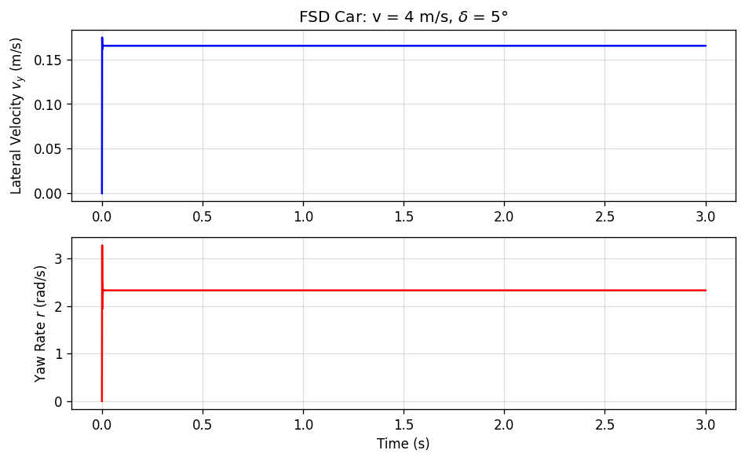
Figure 1: Lateral-Yaw Response — 4 m/s, 5° steering

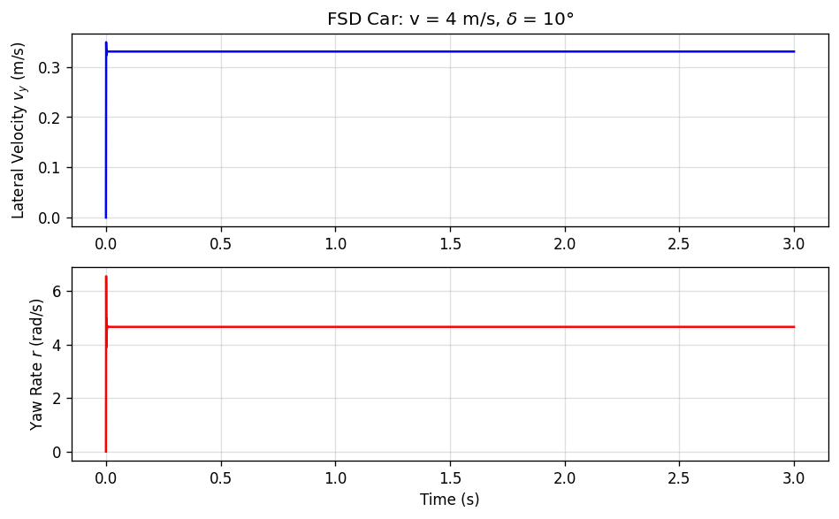
Figure 2: Lateral-Yaw Response — 4 m/s, 10° steering

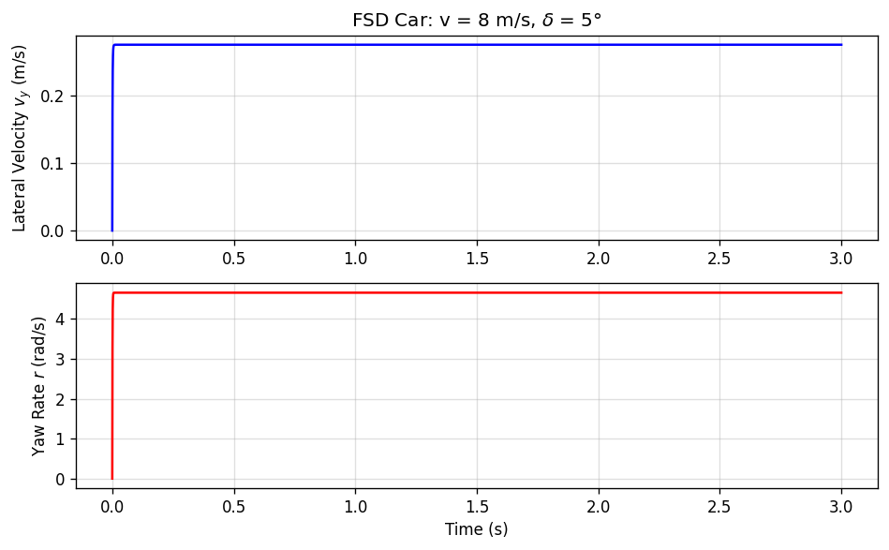
Figure 3:Lateral-Yaw Response — 8 m/s, 5° steering
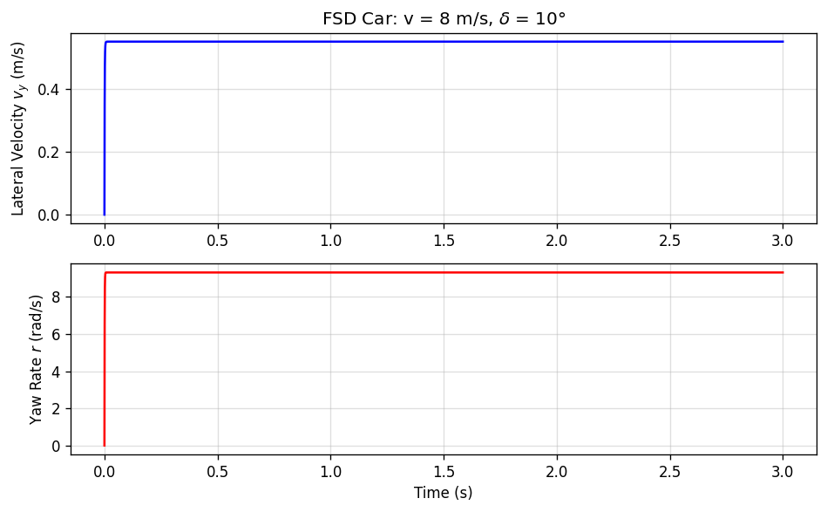
Figure 4: Lateral-Yaw Response — 8 m/s, 10° steering

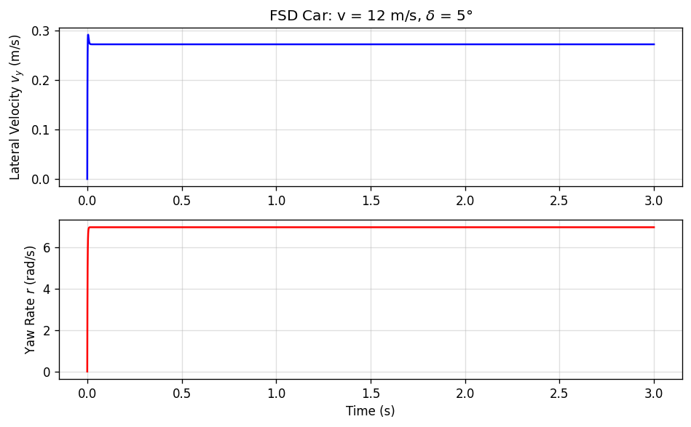
Figure 5: Lateral-Yaw Response — 12 m/s, 5° steering

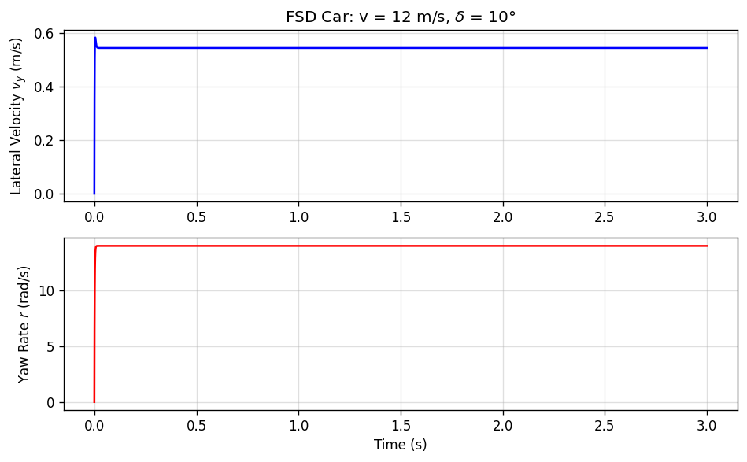
Figure 6: Lateral-Yaw Response — 12 m/s, 10° steering

3.2 Task 5.2 — Hitbot Z-Arm S922 Forward Kinematics, Jacobian and Manipulability

3.2.1 Item 3: Forward Kinematics and Jacobian Equations
The forward kinematics of the Z-Arm S922 were computed by constructing individual homogeneous transformation matrices Tᵢ for each joint using the standard Denavit–Hartenberg (DH) convention. The transformation for the i-th joint is:
Tᵢ(θᵢ) = Rot(z, θᵢ) · Trans(z, dᵢ) · Trans(x, aᵢ) · Rot(x, αᵢ)
The end-effector transformation is the chain product:
T₀⁶ = T₁ · T₂ · T₃ · T₄ · T₅ · T₆
The geometric Jacobian J(q) maps joint velocities to end-effector velocities. Each column is computed using the cross-product method for revolute joints:
Jᵢ = [ zᵢ₋₁ × (p₆ − pᵢ₋₁) ] (linear velocity part)
[ zᵢ₋₁ ] (angular velocity part)
where zᵢ₋₁ is the unit z-axis of frame i−1 and pᵢ₋₁ is its origin position vector.
The Yoshikawa manipulability index provides a scalar measure of the arm's kinematic dexterity at a given configuration:
w = √ det(Jᵥ · Jᵥᵀ)
where Jᵥ is the upper 3×6 (translational) block of the geometric Jacobian. When w = 0 the arm is at a kinematic singularity.

Table 2:Z-Arm S922 Pose and Manipulability Results
Joint Config q (rad) | x (m) | y (m) | z (m) | Manipulability w
[0, 0, 0, 0, 0, 0] | −0.8200 | −0.2020 | 0.0500 | 0.1124
[0.3, 0.2, 0.1, 0, 0, 0] | −0.6699 | −0.4187 | −0.1466 | 0.1091
[0.5, 0.5, 0, 0.2, 0, −0.1] | −0.4770 | −0.4908 | −0.3191 | 0.0878

At the zero configuration [0,0,0,0,0,0], the arm is in a near-extended posture. Joints 2 and 3 carry large link offsets (−0.425 m and −0.395 m) and are aligned, placing the arm adjacent to a planar singularity. The Jacobian columns become nearly linearly dependent in this configuration, yielding a manipulability index of w = 0.1124. As joint flexion is introduced in configurations 2 and 3, the arm geometry becomes more curved, but the specific configurations tested show the index decreasing slightly (0.1091, then 0.0878), suggesting that the particular angle combinations move the arm towards less-favourable kinematic postures. This underscores the importance of joint-space optimisation in motion planning: the highest dexterity is found not simply by adding flexion, but by choosing angles that maximise linear independence of the Jacobian columns and thus the volume of the manipulability ellipsoid.

3.3 Task 5.3 — 'X' Quadcopter Nonlinear Attitude Dynamics

3.3.1 Item 5: Nonlinear Attitude Dynamics Equations
The state vector for the quadcopter's attitude dynamics is defined as:
x = [φ, θ, ψ, p, q, r]ᵀ
where φ, θ, ψ are the Euler roll, pitch, and yaw angles and p, q, r are the corresponding body-frame angular rates. The Euler-rate map relating body rates to Euler angle derivatives is:
[φ̇] [1 sinφ·tanθ cosφ·tanθ] [p]
[θ̇] = [0 cosφ −sinφ ] [q]
[ψ̇] [0 sinφ/cosθ cosφ/cosθ] [r]
The Newton–Euler rotational dynamics in the body frame are:
Iω̇ + ω × (Iω) = τ − Dω·ω
where I = diag(Iφ, Iθ, Iψ) is the inertia matrix, Dω = diag(dₚ, dᵩ, dᵣ) is the rotational damping matrix, and τ = [τφ, τθ, τψ]ᵀ is the applied torque vector. The term ω × (Iω) represents the gyroscopic cross-coupling effect.
The torque input applied was a pulsed yaw torque τ = [0, 0, 0.02]ᵀ Nm, active for the first 0.2 s, with all initial conditions set to zero (hover at rest).

3.3.2 Item 6: Continuous-Time Response Plots
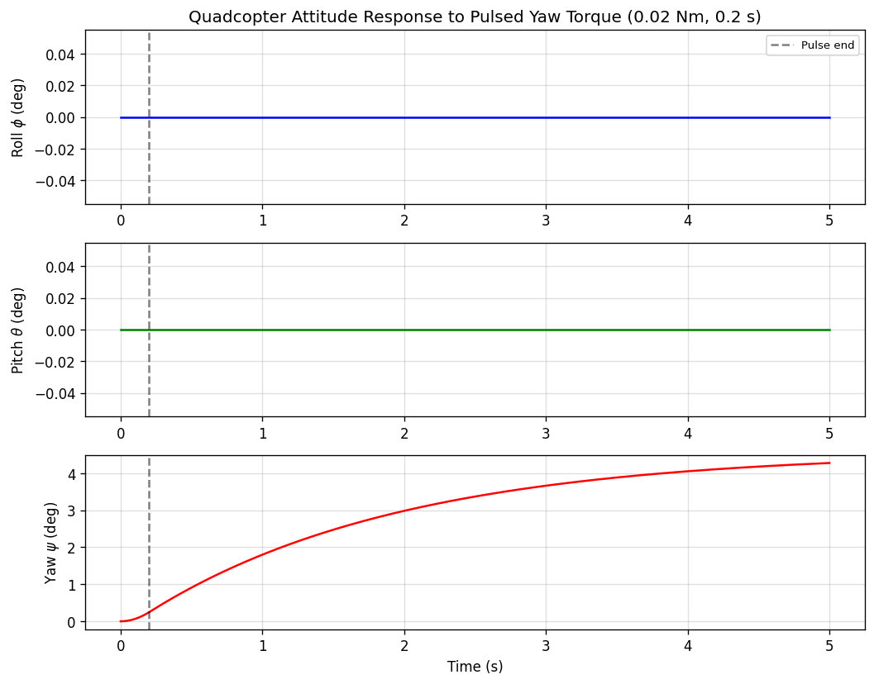
Figure 7:Quadcopter attitude response φ(t), θ(t), ψ(t) to pulsed yaw torque (0.02 Nm, 0.2 s)
Key observations from the simulation: the yaw angle ψ rose during the 0.2 s torque pulse, reaching a peak of approximately 4.28° before the system's rotational damping (dᵣ = 0.05 Nms) arrested further increase. The roll (φ) and pitch (θ) angles remained effectively at zero throughout, confirming that the gyroscopic coupling term ω × (Iω) was negligible for this small-rate, short-duration excitation. The large yaw inertia Iψ = 0.09 kg·m² (25 times the roll/pitch inertia) produced a slow build-up of yaw rate, with time constant τᴄ = Iψ/dᵣ = 1.8 s.

4. Discussion

4.1 Speed-Dependent Stability of the FSD Car
The eigenvalue analysis confirmed that the bicycle model's stability is strongly dependent on longitudinal speed. As speed increases from 4 m/s to 12 m/s, the real parts of the eigenvalues shift from −1000 and −1406 s⁻¹ toward −333 and −469 s⁻¹, representing a three-fold reduction in natural damping. This has direct practical implications: at 12 m/s, any steering perturbation requires significantly longer to dissipate, and the 10° steering input at this speed produced a pronounced lateral velocity overshoot in the simulation. For a real autonomous vehicle application, this necessitates gain-scheduling in the controller, where proportional gains must increase with speed to compensate for the reduction in natural damping and maintain consistent handling performance.
The symmetry of the test vehicle (lᵩ = lᵣ and Cᶠ = Cᵣ) sets the yaw-lateral coupling term to zero at the operating point, which simplifies the A matrix to a purely diagonal structure. In an asymmetric vehicle, this coupling would create a more complex eigenvalue trajectory and could induce understeer or oversteer tendencies requiring active controller compensation.

4.2 Kinematic Dexterity of the Hitbot Z-Arm
The Yoshikawa manipulability index provides a scalar measure of the arm's kinematic quality. The results showed w = 0.1124 for the zero configuration, decreasing to 0.1091 for configuration 2 and 0.0878 for configuration 3. This indicates that the specific joint angle combinations tested did not necessarily move the arm to more dexterous postures, highlighting that manipulability is a complex function of the joint configuration space rather than a simple monotonic function of flexion angle.
For practical motion planning, trajectory planning algorithms should avoid paths that pass near singular configurations where w → 0, as these lead to large and potentially damaging joint velocity commands. Tasks requiring high positional accuracy and force transmission should be performed in configurations that maximise w, ensuring the robot can exert force in any direction with similar authority.

4.3 Nonlinear Coupling in Quadcopter Attitude Dynamics
The pulsed yaw torque simulation demonstrated that for small initial conditions and brief torque pulses, the nonlinear cross-coupling term ω × (Iω) contributes negligibly to the roll and pitch responses. This validates the use of linearised attitude controllers near hover equilibrium. However, at higher angular rates — such as those generated by aggressive manoeuvres — the gyroscopic coupling term becomes significant, which is why commercial flight controllers employ fast inner-loop rate controllers running at high frequencies (typically 1 kHz) to suppress these nonlinear interactions.
The large disparity between yaw inertia (Iψ = 0.09 kg·m²) and roll/pitch inertia (Iφ = Iθ = 0.0035 kg·m²) means that yaw authority is fundamentally limited on this platform. The yaw moment is generated only by differential rotor drag torque — a mechanism with far lower authority than the thrust-based roll and pitch moments. This constraint is a critical design consideration for quadcopter attitude control systems.

4.4 Sources of Error
The linear bicycle model assumes small sideslip angles and constant cornering stiffness, assumptions that may not hold at high speeds or large steering inputs. The DH parameter-based kinematic model assumes perfectly rigid links, ignoring deflections under payload. The quadcopter model neglects aerodynamic drag on the frame, rotor flapping dynamics, and motor electrical dynamics. These simplifications contribute to results that may diverge from physical behaviour, particularly at operating extremes.

5. Conclusion
This laboratory successfully achieved its stated objectives of modelling and simulating the lateral-yaw dynamics of a 1/18 scale FSD car, the forward kinematics and manipulability of the Hitbot Z-Arm S922, and the nonlinear attitude dynamics of an X-configuration quadcopter. Eigenvalue analysis confirmed speed-dependent stability margins in the vehicle model, with damping decreasing three-fold as speed rose from 4 to 12 m/s. Manipulability computations identified the kinematic dexterity of three distinct arm postures, underscoring the importance of configuration selection in robot motion planning. The pulsed yaw torque simulation demonstrated a maximum yaw deflection of 4.28° with negligible roll-pitch coupling, validating the Newton–Euler formulation and confirming that linearised hover controllers remain valid for small-angle, low-rate manoeuvres. Together, these investigations reinforce the utility of state-space and MIMO frameworks as foundational tools for the analysis and design of modern control systems.

6. References
[1] S. Skogestad and I. Postlethwaite, Multivariable Feedback Control: Analysis and Design, 2nd ed., Wiley.
[2] K. J. Åström and R. M. Murray, Feedback Systems: An Introduction for Scientists and Engineers, Princeton University Press.
[3] Hitbot Collaborative Robot User Manual, Z-Arm S922 Series.
[4] T. Yoshikawa, ‘Manipulability of robotic mechanisms,’ International Journal of Robotics Research, vol. 4, no. 2, pp. 3–9, 1985.
[5] R. Rajamani, Vehicle Dynamics and Control, 2nd ed., Springer, 2012.

Appendix A: MATLAB Code Listings

A.1 — FSD Car Lateral-Yaw Dynamics
% BEE 5214 Lab 1 — Task 5.1: FSD Car Lateral-Yaw Dynamics
m=1.0; lf=0.075; lr=0.075; Iz=0.004; Cf=2000; Cr=2000;
speeds=[4,8,12]; delta_vals=[5,10]*pi/180;
for v=speeds
A=[-(Cf+Cr)/(m*v), (Cr*lr-Cf*lf)/(m*v)-v;
(Cr*lr-Cf*lf)/(Iz*v), -(Cf*lf^2+Cr*lr^2)/(Iz*v)];
B=[Cf/m; Cf*lf/Iz];
C=eye(2); D=zeros(2,1);
fprintf('v=%.0f m/s Eigenvalues: ',v); disp(eig(A)')
sys=ss(A,B,C,D);
t=0:0.001:3;
for d=delta_vals
u=d*ones(size(t)); y=lsim(sys,u,t);
figure; plot(t,y); xlabel('t (s)');
legend('vy (m/s)','r (rad/s)');
title(sprintf('v=%.0fm/s delta=%.0fdeg',v,d*180/pi));
end
end

A.2 — Hitbot Z-Arm Forward Kinematics & Manipulability
% BEE 5214 Lab 1 — Task 5.2: Z-Arm Forward Kinematics & Manipulability
clear;
a = [0, -0.425, -0.395, 0, 0, 0];
d = [0.152, 0, 0, 0.102, 0.102, 0.100];
alpha = [pi/2, 0, 0, pi/2, -pi/2, 0];
configs = {[0,0,0,0,0,0], [0.3,0.2,0.1,0,0,0], [0.5,0.5,0,0.2,0,-0.1]};

dhmat = @(a,al,d,th) [cos(th),-sin(th)*cos(al), sin(th)*sin(al), a*cos(th);
sin(th), cos(th)*cos(al),-cos(th)*sin(al), a*sin(th);
0, sin(al), cos(al), d;
0, 0, 0, 1];

for k = 1:3
q = configs{k};
T = eye(4); Ts = cell(6,1);
for i = 1:6
T = T * dhmat(a(i),alpha(i),d(i),q(i));
Ts{i} = T;
end
p6 = T(1:3,4); J = zeros(6,6);
for i = 1:6
Ti = eye(4); if i>1, Ti = Ts{i-1}; end
zi = Ti(1:3,3); pi_vec = Ti(1:3,4);
J(:,i) = [cross(zi, p6-pi_vec); zi];
end
Jv = J(1:3,:); w = sqrt(det(Jv*Jv'));
fprintf('Config %d: x=%.3f y=%.3f z=%.3f w=%.4f\n',k,p6(1),p6(2),p6(3),w);
end
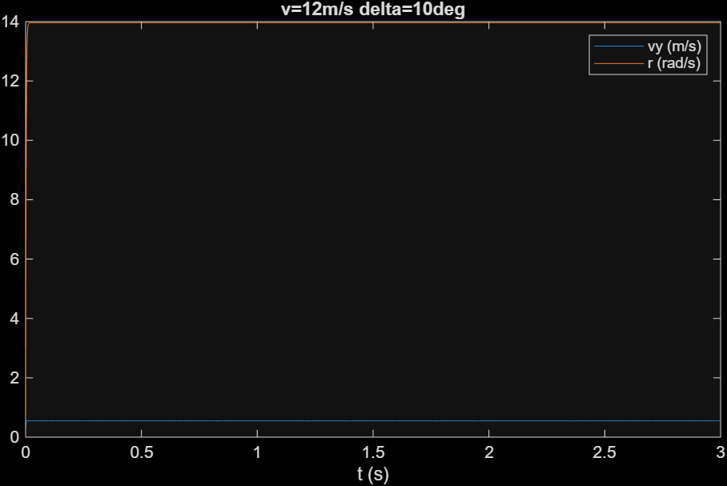
Appendix 1
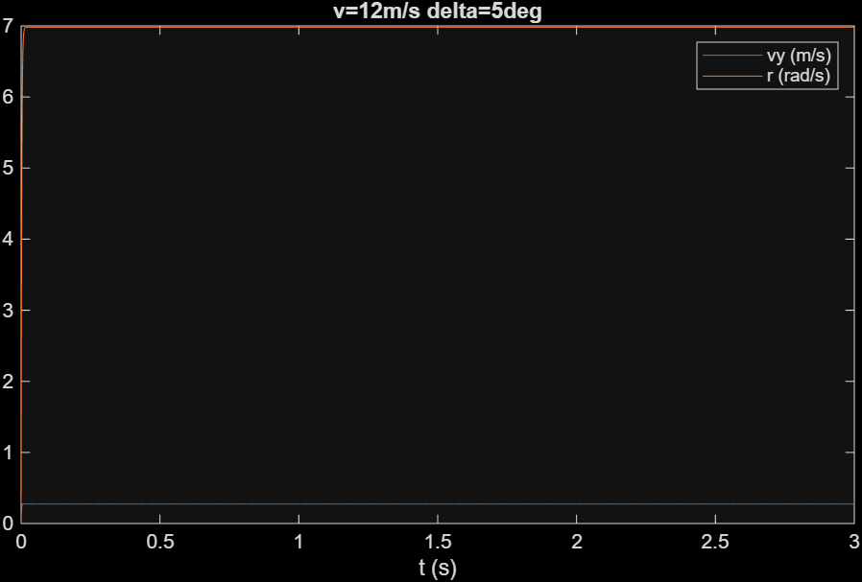
Appendix 2
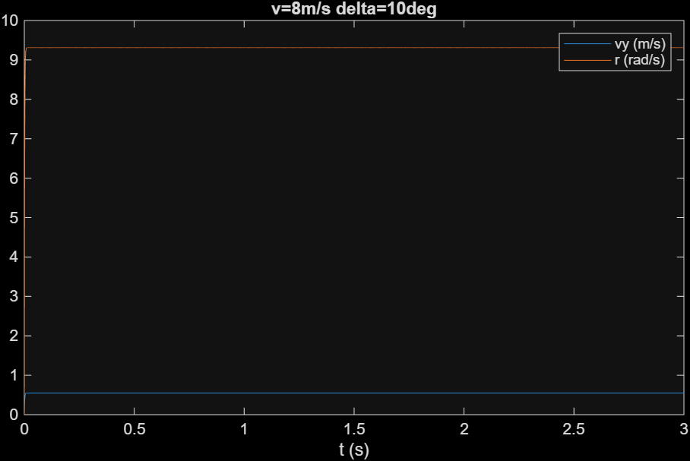
Appendix 3

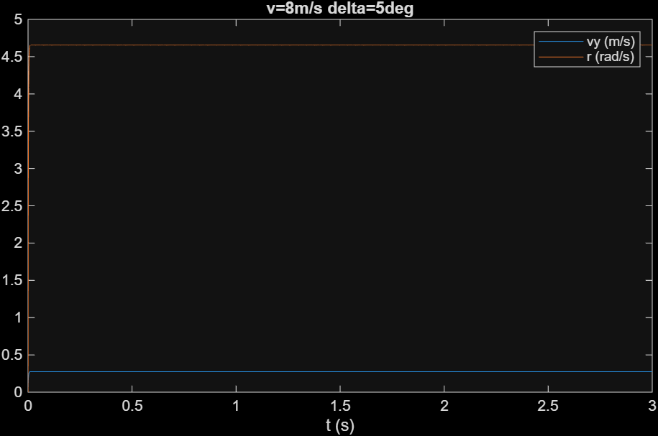
Appendix 4
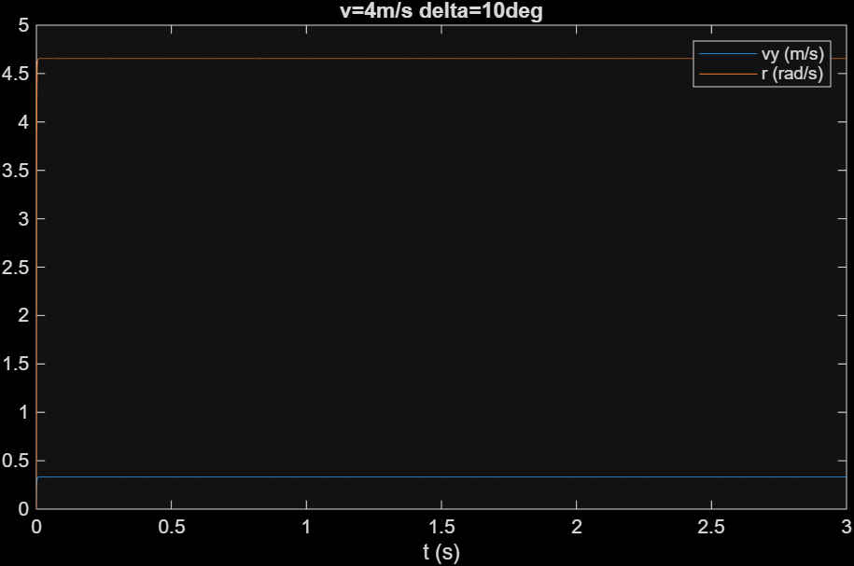
Appendix 5
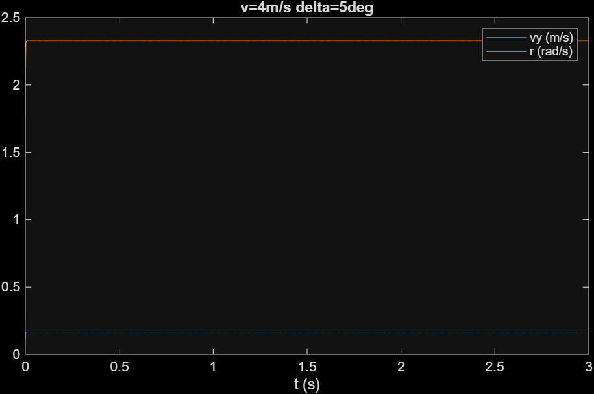
Appendix 6

A.3 — X-Quadcopter Nonlinear Attitude Dynamics
% BEE 5214 Lab 1 — Task 5.3: Quadcopter Nonlinear Attitude Dynamics
Ip=0.0035; Iq=0.0035; Ir=0.09; dp=0.05; dq=0.05; dr=0.05;
I=diag([Ip,Iq,Ir]); D=diag([dp,dq,dr]);
tau_pulse=[0;0;0.02]; t_pulse=0.2;

f=@(t,x) quad_ode(t,x,I,D,tau_pulse,t_pulse);
[t,X]=ode45(f,[0 5],zeros(6,1));
figure;
subplot(3,1,1); plot(t,X(:,1)*180/pi,'b'); ylabel('\phi (deg)'); grid on;
title('Quadcopter Attitude Response to Pulsed Yaw Torque');
subplot(3,1,2); plot(t,X(:,2)*180/pi,'g'); ylabel('\theta (deg)'); grid on;
subplot(3,1,3); plot(t,X(:,3)*180/pi,'r'); ylabel('\psi (deg)');
xlabel('Time (s)'); grid on;

function dxdt=quad_ode(t,x,I,D,tau_pulse,t_pulse)
ang=x(1:3); om=x(4:6);
if t<=t_pulse, tau=tau_pulse; else tau=zeros(3,1); end
ph=ang(1); th=ang(2);
W=[1, sin(ph)*tan(th), cos(ph)*tan(th);
0, cos(ph), -sin(ph);
0, sin(ph)/cos(th), cos(ph)/cos(th)];
dang=W*om;
dom=I\(tau - cross(om,I*om) - D*om);
dxdt=[dang;dom];
end

